Contents

1. Installing Node Js . 1

2. Installing VisualStudio Code :- 7

3. Installing Git Set up 11

4. Creating Angular2 Application 16

5. Creating folder to generate ts, html, css and :- 17

6 .Creating folder to generate service 17

7. Installing Angular material and animation:- 17

8. Installing support Bootstrap in angular :- 18

npm install bootstrap@3 --save 18

9. Build the Project 18

10. Creating Fack json . 18

To Install Chart in project folders 19

*11.* Generating module in Angular2 19

12. Generate new module from command Line 19

# Installing Node Js .

<https://www.npmjs.com/>

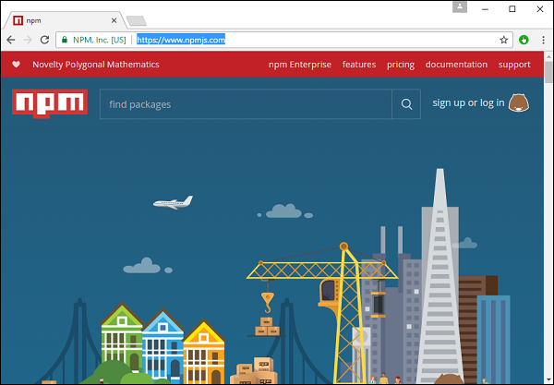

**Step 1** − Go to the “get stated with npm” section in the site.

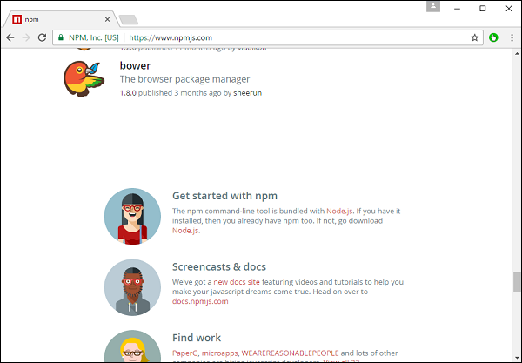

**Step 2** − In the next screen, choose the installer to download, depending on the operating system. For the purpose of this exercise, download the Windows 64 bit version.

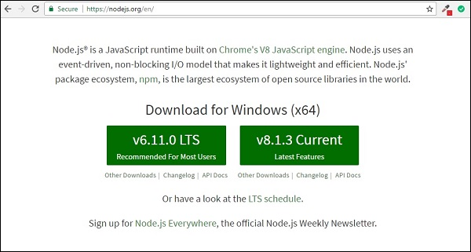

**Step 3** − Launch the installer. In the initial screen, click the Next button.

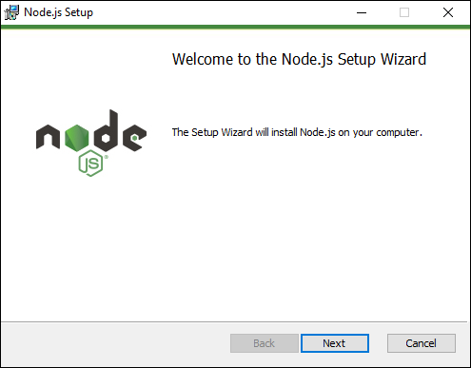

**Step 4** − In the next screen, Accept the license agreement and click the next button.

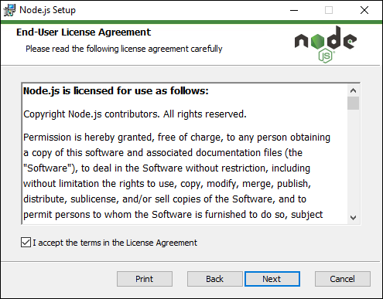

**Step 5** − In the next screen, choose the destination folder for the installation and click the Next button.

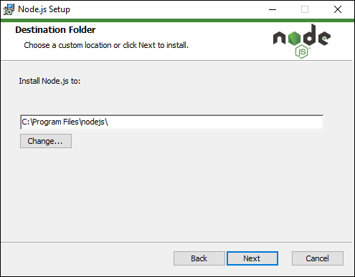

**Step 6** − Choose the components in the next screen and click the Next button. You can accept all the components for the default installation.

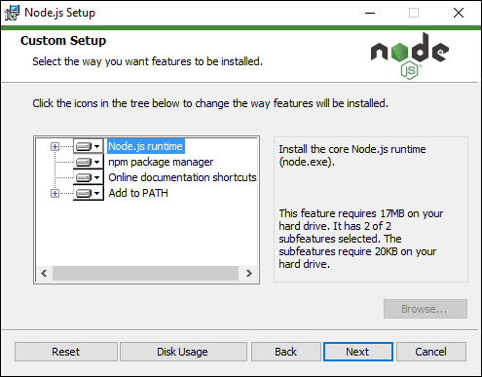

**Step 7** − In the next screen, click the Install button.

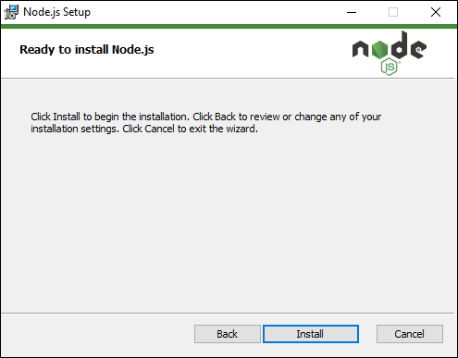

**Step 8** − Once the installation is complete, click the Finish button.

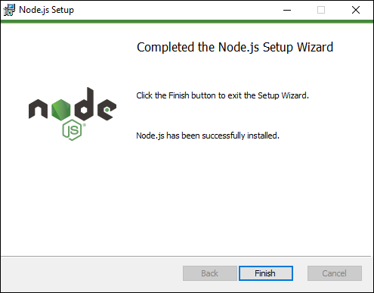

**Step 9** − To confirm the installation, in the command prompt you can issue the command npm version. You will get the version number of npm as shown in the following screenshot.

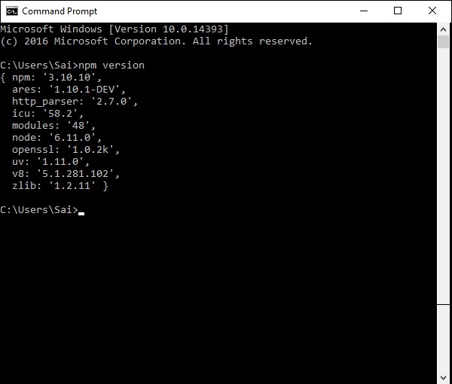

|  |
| --- |
| node --version  npm --version |

If you get the versions Node 4.x.x and NPM 3.x.x. or higher you are all set. If not you have to get the latest versions.

Let’s move on to Angula

# Installing VisualStudio Code :-

Following are the features of Visual Studio Code −

* Light editor when compared to the actual version of Visual Studio.
* Can be used for coding languages such as Clojure, Java, Objective-C and many other languages.
* Built-in Git extension.
* Built-in IntelliSense feature.
* Many more extensions for development.

The official site for Visual Studio code is <https://code.visualstudio.com/>

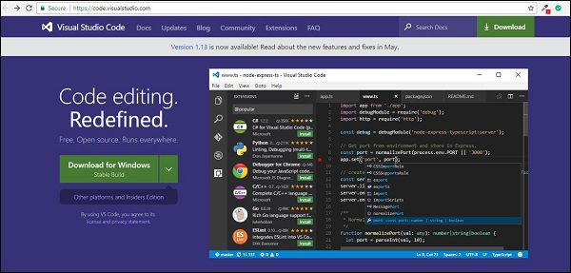

**Step 1** − After the download is complete, please follow the installation steps. In the initial screen, click the Next button.

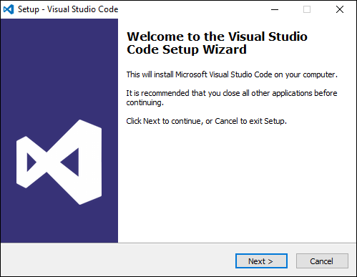

**Step 2** − In the next screen, accept the license agreement and click the Next button.

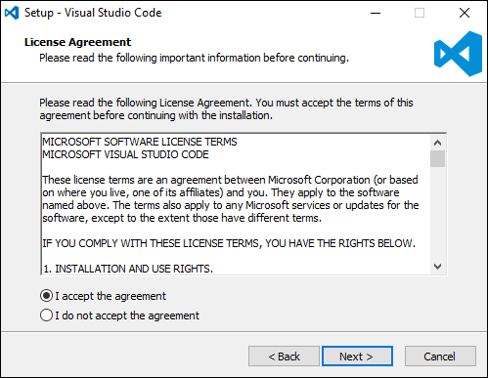

**Step 3** − In the next screen, choose the destination location for the installation and click the next button.

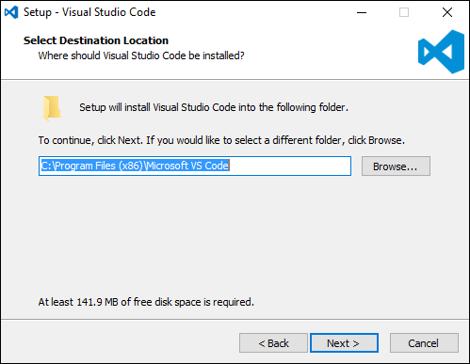

**Step 4** − Choose the name of the program shortcut and click the Next button.

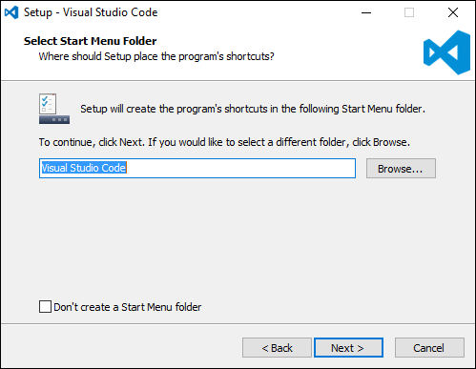

**Step 5** − Accept the default settings and click the Next button.

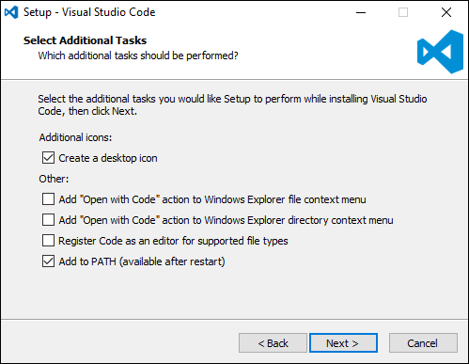

**Step 6** − Click the Install button in the next screen.

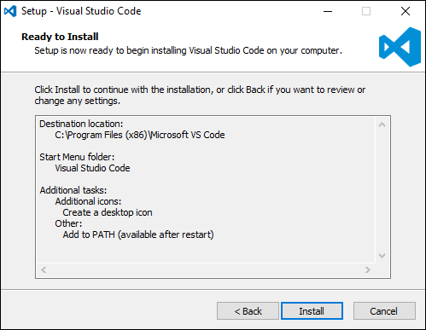

**Step 7** − In the final screen, click the Finish button to launch Visual Studio Code.

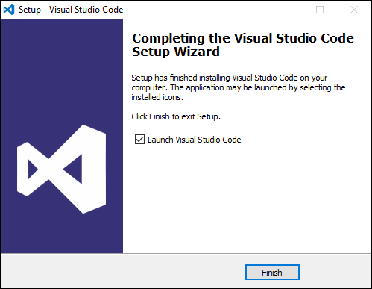

# Installing Git Set up

Some of the key features of Git are −

* Easy branching and merging of code.
* Provision to use many techniques for the flow of code within Git.
* Git is very fast when compared with other SCM tools.
* Offers better data assurance.
* Free and open source.

The official site for Git is <https://git-scm.com/>

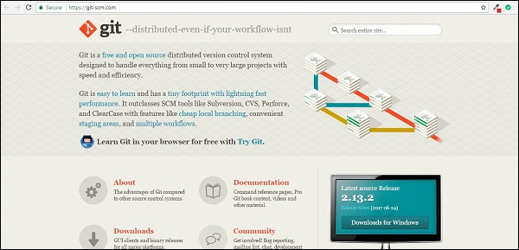

**Step 1** − After the download is complete, please follow the installation steps. In the initial screen, click the Next button.

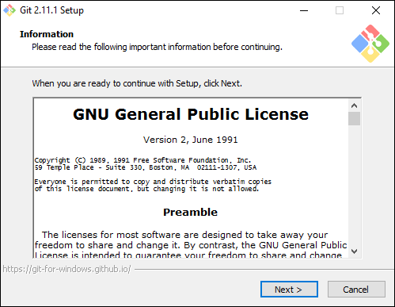

**Step 2** − Choose the components which needs to be installed. You can accept the default components.

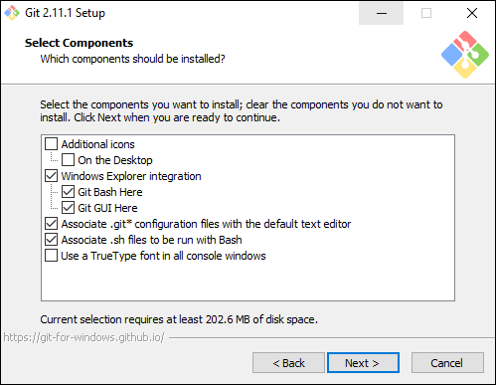

**Step 3** − In the next step, choose the program shortcut name and click the Next button.

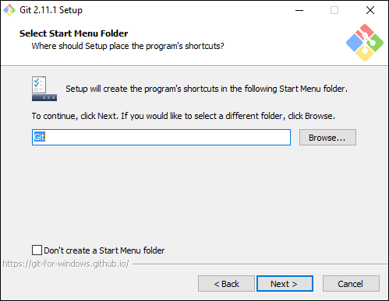

**Step 4** − Accept the default SSH executable and click the Next button.

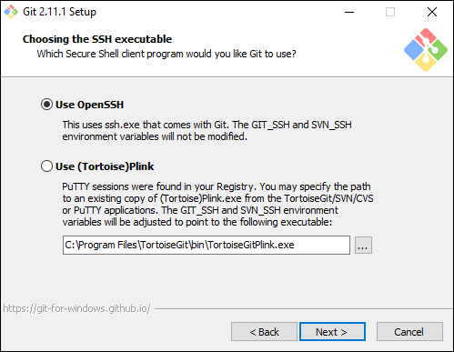

**Step 5** − Accept the default setting of “Checkout Windows style, commit Unix style endings” and click the Next button.

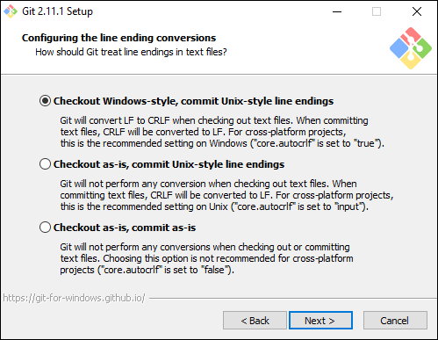

**Step 6** − Now, accept the default setting of the terminal emulator and click the Next button.

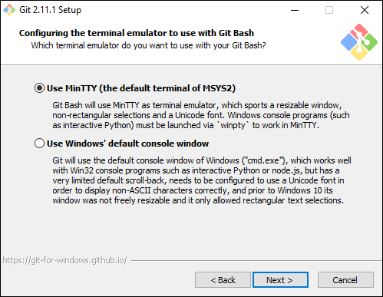

**Step 7** − Accept the default settings and click the Next button.

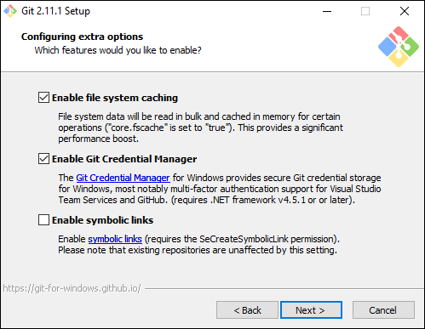

**Step 8** − You can skip the experimental options and click the Install button.

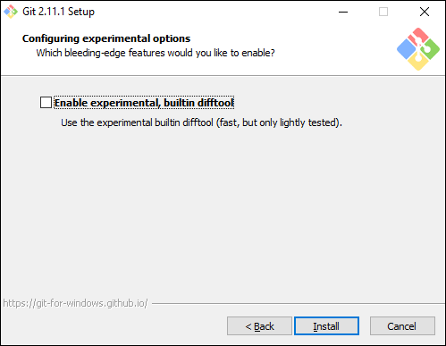

**Step 9** − In the final screen, click the Finish button to complete the installation.

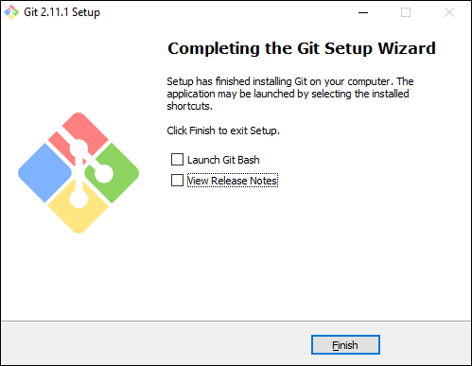

# Creating Angular2 Application

1. 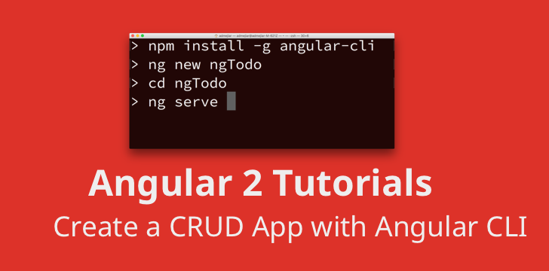

# 5. Creating folder to generate ts, html, css and :-

# 

**ng generate component <folder name>**

*component inside componenet :-*

**ng generate component <Parent folder name/Child FolderName>**

**example :-**

**1. ng generate component employee**

**2. ng generate component employee/employeeCount**

# 6 .Creating folder to generate service

ng generate service weather

# Installing Angular material and animation:-

npm install --save @angular/material @angular/cdk

npm install --save @angular/animations

npm install --save hammerjs

**add global css. In styles.css**

@import "~@angular/material/prebuilt-themes/indigo-pink.css";

Go to main.ts file and add

import 'hammerjs';

Go to index.html and add

<link href="https://fonts.googleapis.com/icon?family=Material+Icons" rel="stylesheet">

# Installing support Bootstrap in angular :-

# npm install bootstrap@3 --save

Once Bootstrap is installed, open .angular-cli.json file and specify the path to the Bootstrap stylesheet (bootstrap.min.css) in the styles property as shown below. 

"styles": [

  "../node_modules/bootstrap/dist/css/bootstrap.min.css",

  "styles.css"

]

# Build the Project

**>>Go to the directory**

***npm build***

***for Production***

***npm build --prod***

***npm build --prod --base-href /whateve***

**For Angular 5 :--**

**ng new ng5 –style =scss --routing**

# Creating Fack json .

**Need to install json server through npm**

*$ npm install -g json-server*

json-server --watch db.json

<http://localhost:3000/employees>

# 

# To Install Chart in project folders

***npm install chart.js –save***

***Other way***

**npm install angular2-fusioncharts –save**

# Generating module in Angular2

|  |  |
| --- | --- |
| down vote | use :  ng g m route --routing   * g-> generate * m-> module * Route-> Your route Module Name(You can use any name). |

# Generate new module from command Line

1. ***ng g m login***

***ng g m route –routing***

***ng g c login***

***ng g m login***